GetOpenTechIncidents()

WCF test (techID = 11) successful (DateClosed null shown below)

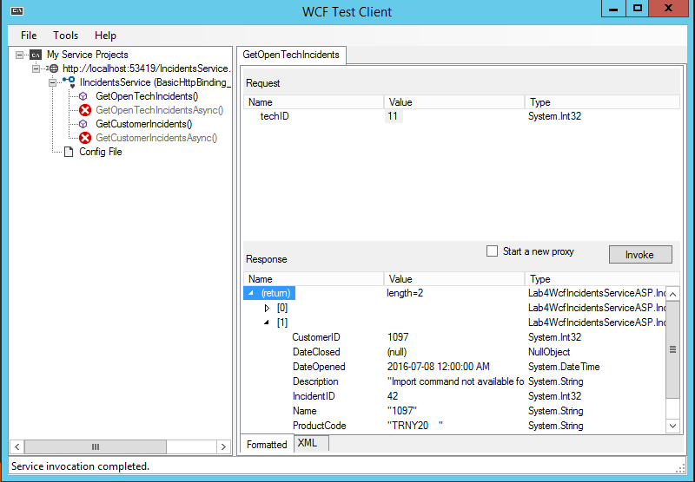

GetOpenTechIncidents()

WCF testing (techID = 12) successful (null DateClosed shown below)

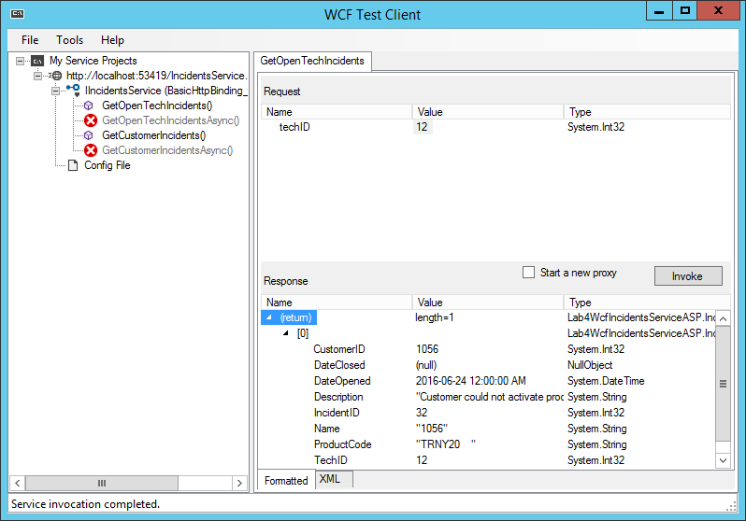

GetCustomerIncidents() WCF testing (techID = 12) successful (null DateClosed shown below

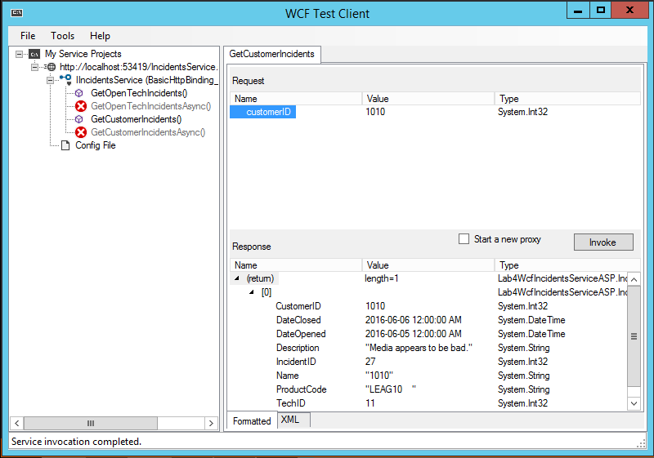

GetCustomerIncidents() WCF testing (techID = 12) successful (null DateClosed shown below 